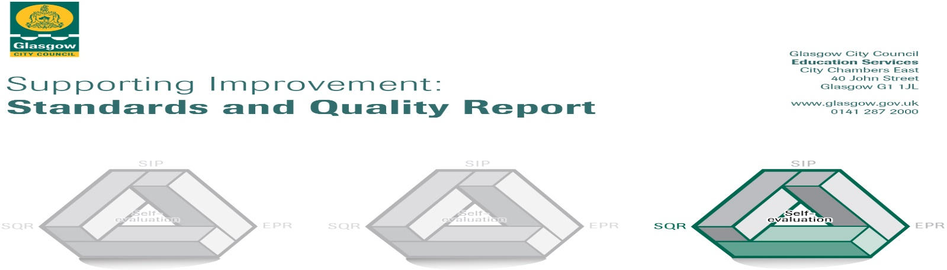
Parkview Primary School
2019/ 2020
The summary report is provided for parents/careers and partners to outline our achievements this session and our priorities for next session. Throughout this session we have taken forward our priorities as detailed in our school improvement plan. Through our processes of self-evaluation, we have identified how we can improve outcomes for our children and young people.
Our achievements and improvements this year.
We would like to highlight the following improvements/achievements:

- Our P1 children quickly settled into school life and have benefitted from a more playful pedagogy
- We have developed our partnership with Wyndford Nursery with well-planned transition activities happening throughout the year which have benefitted our P1 children including those pupils from other nurseries
- We had 2 successful open afternoon and 2 parents nights last year both with increased attendance.
- Our P2 children have benefitted from a more playful pedagogy in P1 and this has continued into P2
- All children have benefited from teaching strategies that staff have deployed following training from Glasgow Dyslexia Support Service.
- Our staff are more trauma aware and respond to children’s needs accordingly
- Our Nurture Group has been successfully supporting children to develop essential skills
- Our children continue to be engaged with Accelerated reader to develop reading skills
- Six of our P7 children completed the Scholars’ Programme with The Brilliant Club and Strathclyde University, with the aim is to encourage more children to aim to go to university.
- Our children who speak English as an Additional Language have made good progress developing their English language skills thanks to new resources and increased opportunities for family learning and information sharing thanks to our regular drop-in café.
- We have developed partnerships with various 3rd Sector organisations and have been able to participate in programmes of great benefit to our children and their families. Including receiving a great amount of food from Fare Share Move On, a third sector organisation that aims to stop food waste and food poverty.
- Our pupils have had more opportunities to make their voices heard and opinions known in our Family Grouping
- We have worked successfully with our parent council giving thought to ensuring we are reducing the pressures which school costs place on families and as such have secured grants for extras for our pupils.
- We have developed our playground with the help of grants secured by our Parent Council
- We are developing our outdoor Learning space with the help of grants secured by our Parent Council
- We had a very successful World of Work Day in which the children spoke with members of our school community about the huge variety of jobs the do.
- The Celebration of our community in our 1st Annual International Day, was a huge success with pupils and parents across our school community
- We have brought theatre companies into school to enhance learning experiences in areas such as Literacy, Numeracy, Science and Bullying.
- Our children have enjoyed clubs such as
  - Arts and Craft
  - Games Club
  - Guitar
  - Choir
  - Football
  - Dance
  - Rugby
  - Christmas Crafts
  - Basketball
- 120 members of our community joined together and enjoyed a family Christmas meal in partnership with Fare Share Move On

Here is what we plan to improve next year.
Family Learning
- We will be seeking ways to maximise opportunities to engage with our families and will be seeking views on parents’ nights and family learning activities.
Literacy
- Raising attainment in Literacy (Reading, Writing, Talking and Listening)
Digital Literacy
- We are delighted to be planning for our Glasgow City Council’s new digital strategy. Parkview will be receiving an ipad for every child P5-P7 and 1 per 5 children P1-4. We will all be working hard to navigate the ipad and all it can offer to aid our children’s learning.

STEM (Science, Technologies, Engineering and Maths)
- Science- Develop how we teach Science including a Project with other schools in Cleveden Learning Community led by Miss Gann
- Maths – Development of Number Talks and some new resources

Developing Well-being and Inclusion
- Further develop our school’s approach to Positive Relationships
- Staff learning with our colleagues in the Cleveden Learning Community as each school shares its good practice at the Cleveden Nurture Conference
- Developing a whole school approach to Emotional Literacy (well-being}

We are continually working to improve our school and we are going to do some work this year to develop our school as a Learning Organisation.

How can you find out more information about our school?
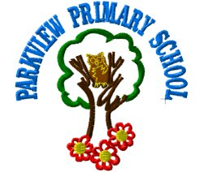

Please contact us directly if you require further information or if you wish to comment on the report.

The contact e-mail address is:Headteacher@parkview-pri.glasgow.sch.uk

Our telephone number is:0141 946 4622

Our school address is: 19 Rothes Drive Glasgow G23 5PZ

Twitter @PrimaryParkview
www.parkview-pri.glasgow.sch.uk

Further information is available in: newsletters, the school website and the school handbook.

