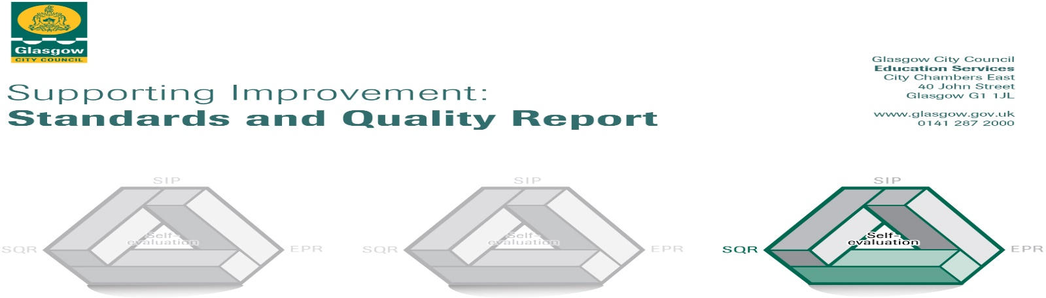
Parkview Primary School
2018/ 2019
The summary report is provided for parents/careers and partners to outline our achievements this session and our priorities for next session. Throughout this session we have taken forward our priorities as detailed in our school improvement plan. Through our processes of self-evaluation, we have identified how we can improve outcomes for our children and young people.
Our achievements and improvements this year.
We would like to highlight the following improvements/achievements:
- Our staff are more trauma aware and respond to children’s needs accordingly
- Our Nurture Group has had a successful start and has been supporting children to develop essential skills
- Our children continue to be engaged with Accelerated reader
- Our children who speak English as an Additional Language have made good progress developing their English language skills thanks to new resources and increased opportunities for family learning and information sharing thanks to our regular drop-in café.
- Our P2 children have benefitted from a more playful pedagogy in P1 and this has continued into P2
- We have developed our partnership with Wyndford Nursery with well-planned transition activities happening throughout the year which have benefitted our P1 children including those pupils from other nurseries
- We had 2 successful open afternoon and 2 parents nights last year both with increased attendance.
- We have developed partnerships with various 3rd Sector organisations and have been able to participate in programmes of great benefit to our children
- Leadership at all levels- with more opportunities for teacher and pupils
- We continue our work successfully with our parent council giving thought to ensuring we are reducing the pressures which school costs place on families and as such have secured grants for extras for our pupils.
- We have developed our playground with the help of grants secured by our Parent Council
- We are developing our outdoor Learning space with the help of grants secured by our Parent Council
- We have brought theatre companies into school to enhance learning experiences in areas such as Literacy, Numeracy, Science and Bullying.

Here is what we plan to improve next year.
Self-Evaluation
- Gather views of parents

More Effective use of data
- More Opportunities for children to lead learning
- Greater understanding of Children’s Rights
- Tracking Engagement of Pupils
The Curriculum
- Develop our Curriculum Rationale (What we teach and why)
- Develop our Talking and Listening Curriculum
- Develop our use of technology
  - Buying more technology
  - Training Staff (digital Literacy & technology )
Learning, Teaching and Assessment

Improve planning for learning, teaching and Assessment
- Improve L&T through Pedagogy and Equity Programme Improve P1 & P2 L & T by developing more playful pedagogy

Ensuring Well-being, Equality and Inclusion
The Nurturing School

Develop Relationships Policy to ensure consistency across the school and understanding across the school community
- Further engage parents as partners

Raising Attainment and Achievement
- More opportunities for Outdoor Learning including improving space
- Use of data to target interventions with specific children
- More effective moderation activities- more opportunities for staff to work together

How can you find out more information about our school?
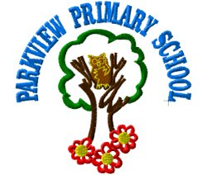

Please contact us directly if you require further information or if you wish to comment on the report.

The contact e-mail address is:Headteacher@parkview-pri.glasgow.sch.uk

Our telephone number is:0141 946 4622

Our school address is: 19 Rothes Drive Glasgow G23 5PZ

Twitter @PrimaryParkview

Further information is available in: newsletters, the school website , and the school handbook

