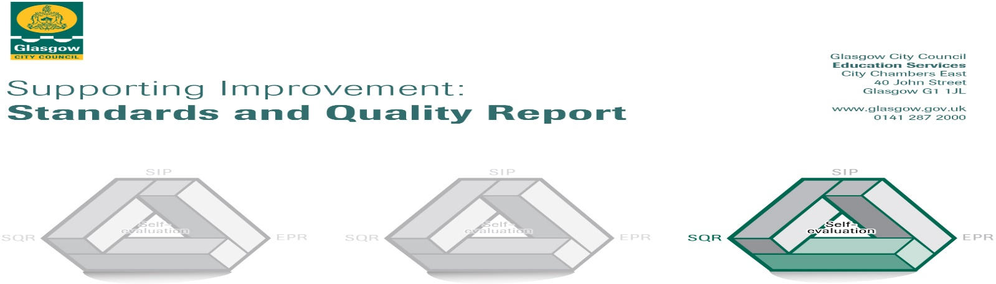
Parkview Primary School

The summary report is provided for parents/careers and partners to outline our achievements this session and our priorities for next session. Throughout this session we have taken forward our priorities as detailed in our school improvement plan. Through our processes of self-evaluation, we have identified how we can improve outcomes for our children and young people.
Our achievements and improvements this year.
We would like to highlight the following improvements/achievements:
- We have continued to improve our children’s academic achievements. We have more children achieving a level in Curriculum for Excellence within the suggested timescales.
- Our Attainment Challenge project to improve reading has been very successful. More children are reading and enjoying reading and are making progress more than or equal to the months/time.
- Accelerated reader, which tracks children’s reading, has proven to be inspirational to our children.
- More families have been engaging with our school activities e.g. Family Book Club, Parents Evenings,
- Our children have benefitted from a very successful Scotland Reads project and paired reading with consistent volunteers.
- Our children have enjoyed Film literacy for the first time as our staff have developed skills in this area, led by our Challenge Leader of Learning (CLOL)
- Our CLOL has led very successful book week and our children have benefitted from meeting visiting authors.
- Our children have benefitted from a two year collaboration dance project with YDance.
- Our Family Grouping sessions, led by upper school pupils continues to be successful in developing pupil voice within the school.
- We have an excellent relationship with our Parent Council and with them we have secured a number of grants for
  - improvements to our playground
  - More outdoor learning resources
  - Outdoor clothing for pupils
  - More resources for our EAL pupils
- Using Kitbags and Restorative Approaches has helped children express their emotions
- We have further developed our partnership with PEEK and our children are now developing their play skills.
- We have foster a good relationship with Generation Science and who have secured grants for free science shows for our school.
- We are proud of our work to reduce the Cost of the School Day for our families.

Here is what we plan to improve next year.
- Leadership at all levels- with more opportunities for teacher and pupils
- Increase the number of afterschool opportunities and track participation
- Develop play opportunities and outdoor education throughout the school
- Develop P1 pedagogy (how we play learning experiences)
- Work toward The Nurturing School
    - More opportunities for our staff to become aware of how Adverse Childhood Experiences can affect children
    - More work on the nurture principles
- We will review our assessment procedures to take into account the introduction of National Assessments at P1, P4 and P7
- Further develop feedback to children to ensure that children understand how well they are doing and they can improve
- We will increase the resources to help children who are new to English and/or those with EAL
- We will increase opportunities for parents to engage with the school
- We will increase our reading resources digital and books
- We will improve our library.

How can you find out more information about our school?
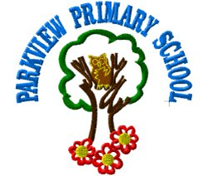

Please contact us directly if you require further information or if you wish to comment on the report.

The contact e-mail address is:Headteacher@parkview-pri.glasgow.sch.uk

Our telephone number is:0141 946 4622

Our school address is: 19 Rothes Drive Glasgow G23 5PZ

Twitter @PrimaryParkview

Further information is available in: newsletters, the school website (coming soon), and the school handbook

